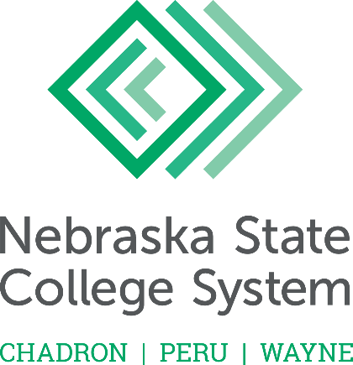

2022 Teaching Excellence Award Nomination Form
Please send nominations to the college’s academic vice president by Monday, September 27, 2021.
The nominee cannot have received this award in the past seven years (no later than 2014)

I wish to nominate the following full-time faculty member for the Nebraska State College System Teaching Excellence Award. I have provided a letter of support that addresses the criteria for the award. This nomination will be shared with the person nominated.

Nominee Information
Name

College ______________________________________________________________________

Rank and Department

Address

Telephone

Primary Nominator Information
Name

Designation (faculty, student, alumni, etc.)

If student, please list class rank and major

Address

Telephone

I affirm that I am not a relative, spouse, or significant other of the nominee.

Signature of Primary Nominator Date

